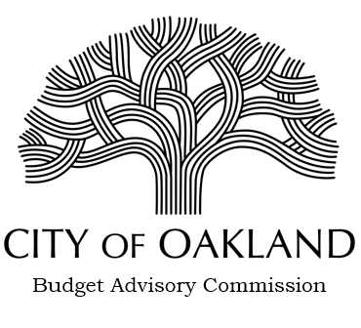

June 3, 2021

To: Members Oakland City Council
From: Jay Ashford, Chair Budget Advisory Commission
Re: Report on Fiscal Year 2021-2023 Budget

Pursuant to the Consolidated Fiscal Policy the Budget Advisory Commission has completed its initial report on the Fiscal Year 2021-2023 Budget. The Report covers both the process to date for adoption of the Budget and recommendations relative to the content of the Budget.

Recognizing the challenges circumstances facing adoption of Budget due to the Covid epidemic we have made a number of recommendations intended to deal with both immediate and long-term fiscal solvency. We look forward to presenting the attached report to the Council and are available to answer any questions you may have.

