Rent a free laptop for your family! Tech support included!

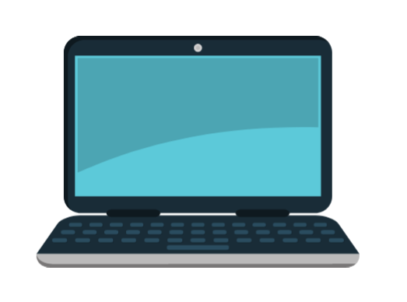
CITY OF OAKLAND HEAD START
TECHNOLOGY
LENDING LIBRARY
2020-2021 and beyond!

What is the Technology Lending Library?
The Technology Lending Library's purpose is to provide every Oakland Head Start family with the technology your family may need. This year, the library includes touchscreen laptops and tech support. The library will hopefully be expanded in future years. All technology is available for families to rent for free and must be returned or renewed at the end of the program year. For 2020-2021, there is a limit of one laptop per family.

How can I receive technology from the library?
To receive a touchscreen laptop, you will need to: 1) be an Early Head Start/Head Start family, including Home-Based families 2) complete a check-out form and 3) pick up the laptop from a Distribution Day. Family Advocates will contact you to help complete the form. Family Advocates will also inform you of the day, time, and place of the Distribution Days.

How long can I rent the technology?
You can rent the technology until the end of the program year. This year, the laptops must be returned in June 2021. You will have the option to renew your laptop rental if you have a child enrolled in the next program year (2021-2022) if you complete a renewal form.

You say this is free? What if the technology is lost, stolen, or damaged?
The laptop is free to rent. You will not be charged a fee if the technology is lost, stolen, or damaged. You will be asked to complete a form documenting what happened. Additionally, you may not be able to get a replacement device. However, our goal is to make the library easy to use and accessible!

What about tech support?
We are partnering with Tech Exchange to provide you with free tech support in multiple languages. Tech Exchange is available Monday–Friday, 9 am–5 pm at 510-866-2260, over the phone and over text in English, Spanish, and Mandarin. Visit techexchange.org for more info.

