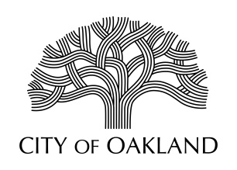

Cultural Affairs Division
Economic & Workforce Development Department

Public Art Advisory Committee
Regular Meeting
Monday, November 5, 2018

Meeting Cancelled

Oakland Cultural Affairs - Public Art Program, 1 Frank H. Ogawa Plaza, 9th fl. Oakland, CA 94612 www.oaklandculturalarts.org

