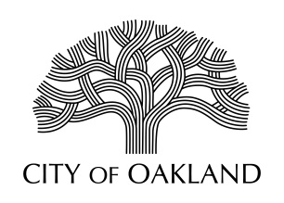
Cultural Affairs Division
Economic & Workforce Development Department

Public Art Advisory Committee
Regular Meeting
May 4, 2020

Oakland City Hall
Hearing Room 4
1 Frank Ogawa Plaza
5:30 - 7:30 pm

MEETING CANCELLED

Next regular meeting: June 1, 2020, Hearing Room 4, Oakland City Hall

Oakland Cultural Affairs - Public Art Program, 1 Frank H. Ogawa Plaza, 9th fl. Oakland, CA 94612 www.oaklandculturalarts.org

